Kentucky Board of Social Work, 125 Holmes Street, Suite 310, Frankfort, KY 40601

Web site address: https://bsw.ky.gov General Email: KBSWinfo@ky.gov

Phone number: 502.564.2350
KENTUCKY BOARD OF SOCIAL WORK QUARTERLY NEWSLETTER

Social Work Board Members and Board Staff

**ANNOUNCEMENTS**

We are happy to share that we have two new board member. Welcome Sydney Whitaker and Cowann Owens to the board! We look forward to working with each of you.

August 2025

Whitney Cassity-Caywood, Ph.D, LCSW,
Vice-Chair
Paducah, KY

Sydney Whitaker, LCSW
Whitesburg, KY

Cowann Owens, LCSW
Louisville, KY

Hank Cecil, LCSW, Chair
Mayfield, KY

Laura Guffey, LSW, Secretary
Edgewood, KY

Vacant, Citizen at Large
KY

Genesia Kilgore-Bowling, Ph.D, CSW
Pikeville, KY

Marc Kelly, LCSW
Executive Director

Vanessa Jones, B.S.
Executive Assistant

Brooke Jones
Administrative Assistant

2025 Board Meeting Dates
January 13 July 14
February 10 August 11
March 31 September 8
April 28 October 13
May NO meeting November 17
June 9 December 8
All board meetings are held at 125 Holmes Street, Suite 310, Frankfort KY and are open to the public. Please join us when you can. You can also watch via our Utube channel KBSW when it works properly. The link is on our website.
Board dates above are subject to change.

Have you moved, changed employers, or had a name change?

Let us know by making these changes using the Self-Service Portal on the Board website below…..
https://bsw.ky.gov

You may also email Board staff or call the office

**Do I only need to submit my supervised experience documentation forms in order to get approved to take the clinical exam?**
NO, you must apply online at the board website for the LCSW exam/license. You will add them when you submit your application.
**I am working under a temp permit supervision contract, so once I get my CSW do I continue working under it or submit a CSW in supervision contract?
NO, you do not continue working under the temp contract. You must submit a CSW in supervision contract and receive an approval email from the board. Once it is approved, you will begin supervision toward your LCSW. The temp permit contract is different than your CSW in supervision contract and the hours you obtain under the temp permit DOES NOT count toward your LCSW.
**As a CSW in supervision, can I be a 1099 employee?**
NO, you must be a W2 employee with taxes taken out of your pay.
**If I have already submitted an application, do I submit one again once I pass the exam?**
NO, you do not apply again. Once you pass your exam follow the directions in your approval email notice or contact the office for further directions.
**FREQUENTLY ASKED QUESTIONS**

** **

**Things To Do**
- The new system will email you a wallet card and a wall certificate once your license is issued there. We will no longer mail out “official” wall certificates; however, if you want one, you can go to the website, submit a request for a wall certificate and pay the $25 fee there or you can contact the office and we can help you.
- If you are a graduate student, you can apply to take your exam 6 weeks prior to your graduation date. You must submit your unofficial transcript to get you approved, so be sure to add it to your application. Then once you pass your exam, we must have your official transcript with your degree awarded sent to us directly from your school before we can issue any license, including the temp permit license.
- If you want to stay up to date on the COMPACT; you can find information on ASWB website; as well as, find resources for your exams. The compact will not be available for a least one year.
- ALWAYS keep your mind active and take time of yourself!!

“We cannot teach people anything; we can only help them discover it within themselves.”

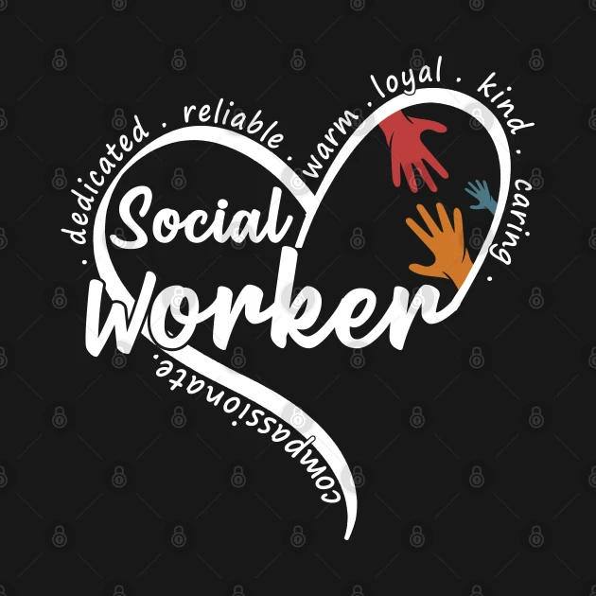

**Reminders**
- If your license is issued in our new system and your license number starts with letters, then you or anyone else, such as an employer, must contact the board office for license verifications. At this time, the license verification section is not active in the new system. If you were issued your license in the old system, then you can go online and purchase it or do a license lookup on the website.
- When you are ready to work toward your LCSW, be sure to submit a CSW in supervision contract to the board office for approval first. You cannot start supervision until you receive an approval email.

Our new system is still in the transition stages and the only active section at this time is the application section. So if you are a new applicant, you will submit your application within that system from the links on our website. No other sections are available at this time. We will keep you updated as the data is migrated and the other sections are active and ready for use.

All new applications, including new temporary license applications, must be submitted online. But first be sure you have a license application on file (for example a CSW application), that we have your official transcript from your school and we have approved you to take your ASWB exam and sent you an email approval notice. Once we have all of this you can apply for the temporary license if needed.
If you were issued a temporary license prior to April 2025 and you need to renew it, then you need to contact Vanessa Jones for more information.

All CSW in supervision contracts are now submitted online. If you have any questions about it you can contact Marc Kelly or assistance.

Our anticipated go live with the full system is October 2025.

